Animation

Animation refers to the movement on the screen of the display device created by displaying a sequence of still images. Animation is the technique of designing, drawing, making layouts and preparation of photographic series which are integrated into the multimedia and gaming products. Animation connects the exploitation and management of still images to generate the illusion of movement. A person who creates animations is called animator. He/she use various computer technologies to capture the pictures and then to animate these in the desired sequence.

Animation includes all the visual changes on the screen of display devices. These are:

1. Change of shape as shown in fig:

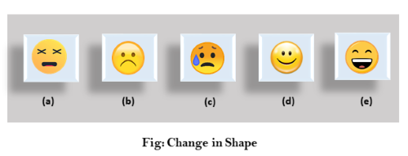

2. Change in size as shown in fig:

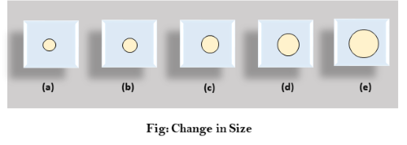

3. Change in color as shown in fig:

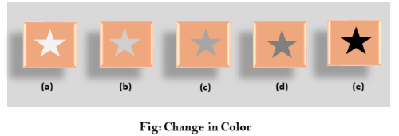

4. Change in structure as shown in fig:

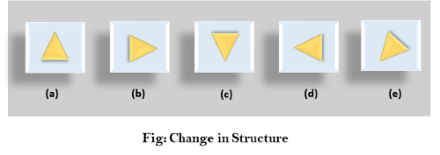

5. Change in angle as shown in fig:

